Performance matric in regression and classification and unsupervised machine learning

**Classification:**

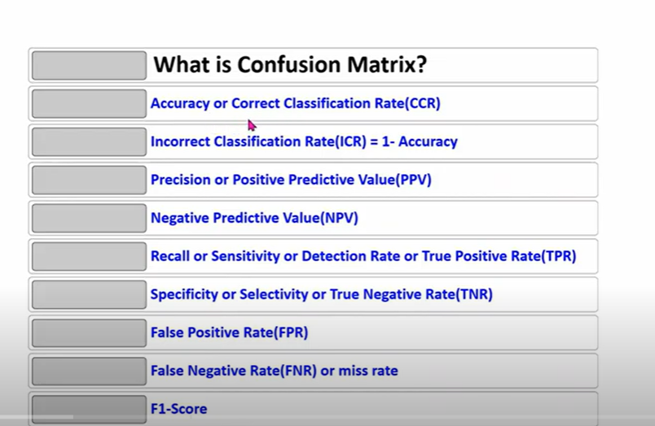

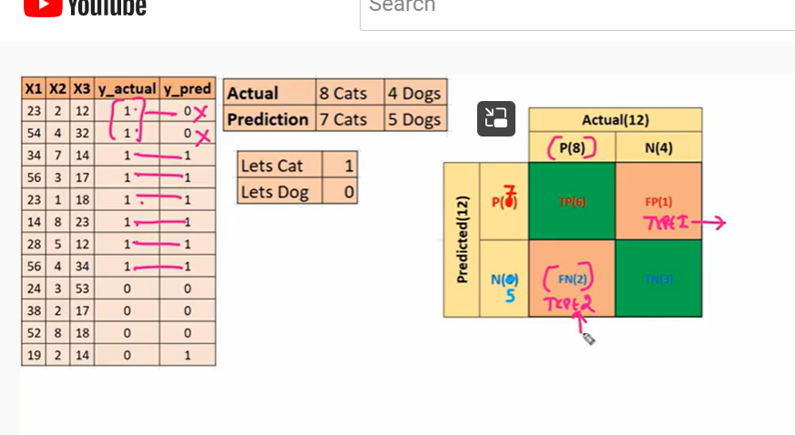

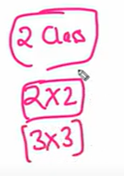

**Sklean library, confusion matrix**

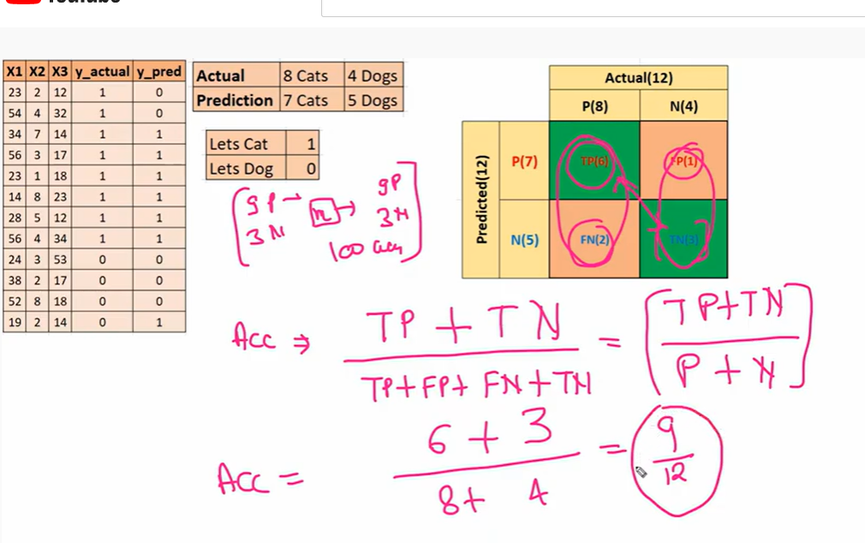

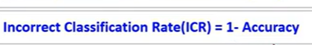

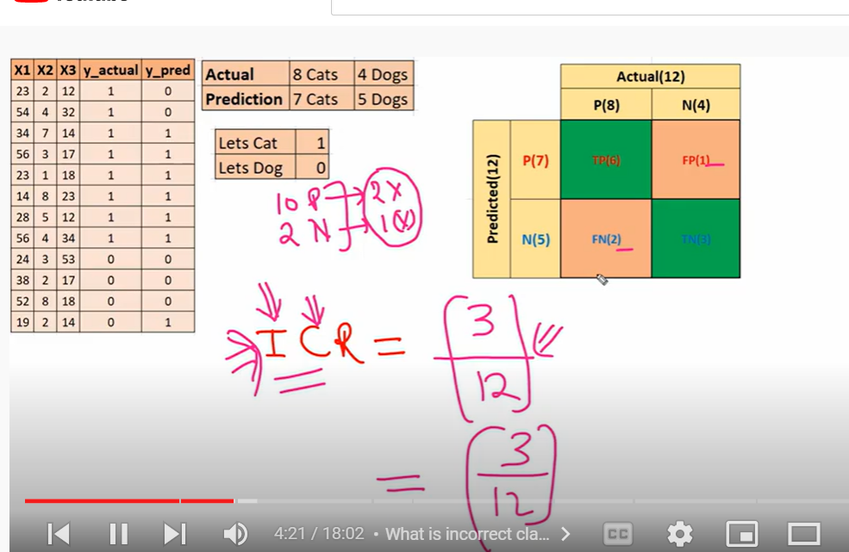

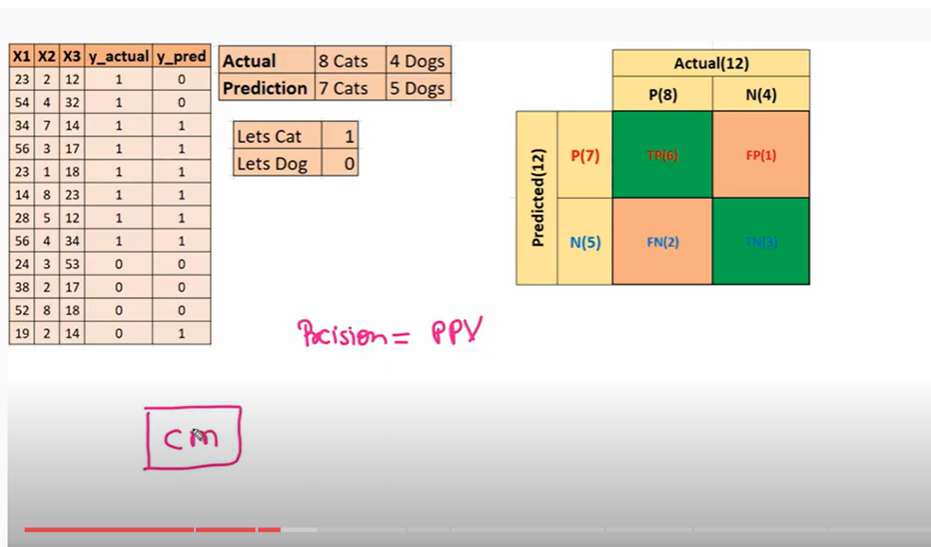

**How precise when u r predicting value**

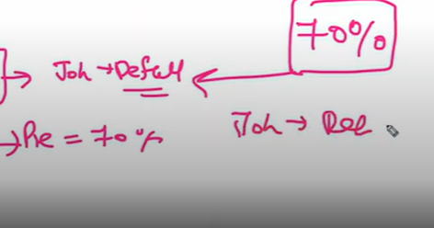

**Model is 70 percent correct for predicting john as defaulter or positives**

**Where as 30 percent is not**

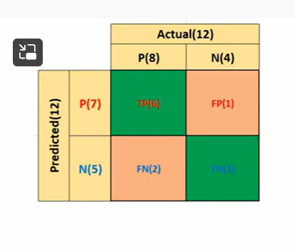

**How many predicted positives, how many are correct**

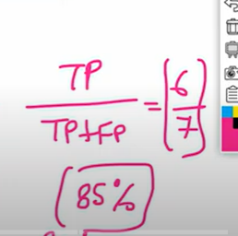

So model is 85 percentage accurate in predicting positives

Out of total positives my model is predicting only 6 as positives, 1 is not able to predict

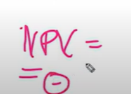

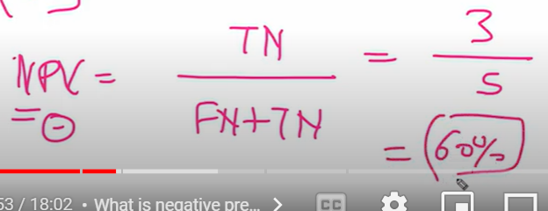

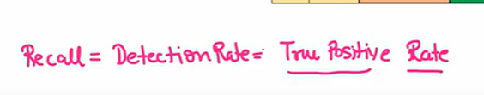

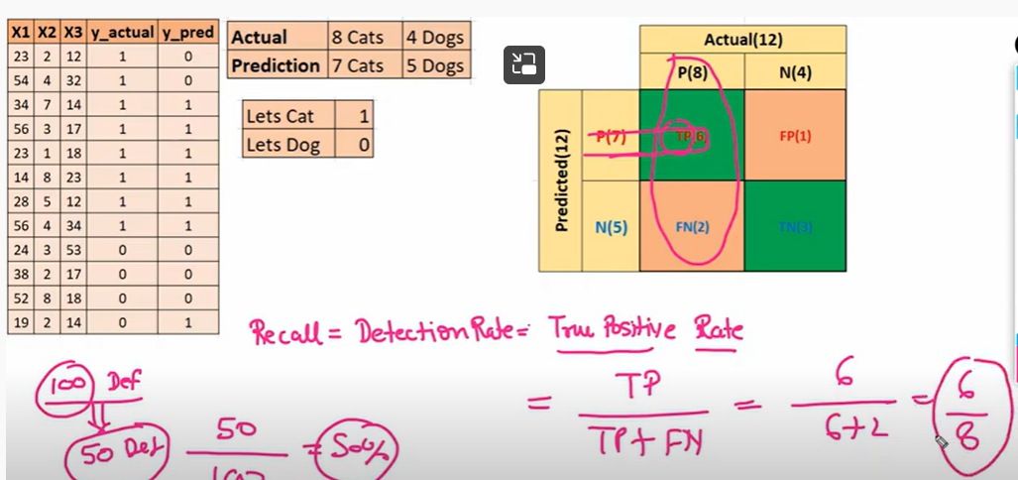

Total 8 true positives(in actuality) but my model predicted only 6 as true positives

How many actual positive , but model predicted only 6

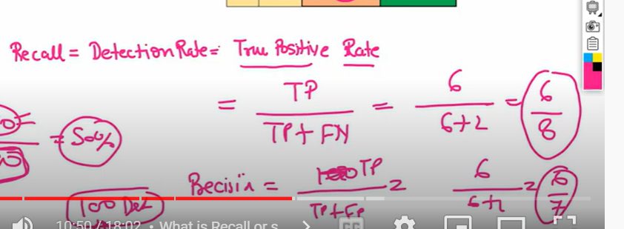

Specificity

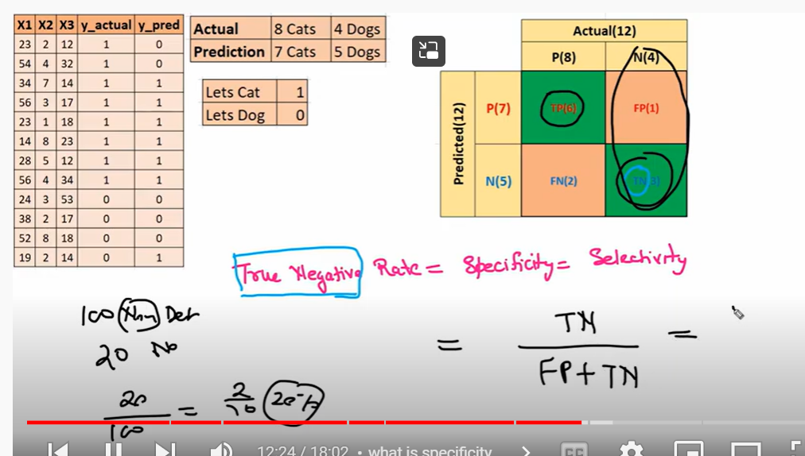

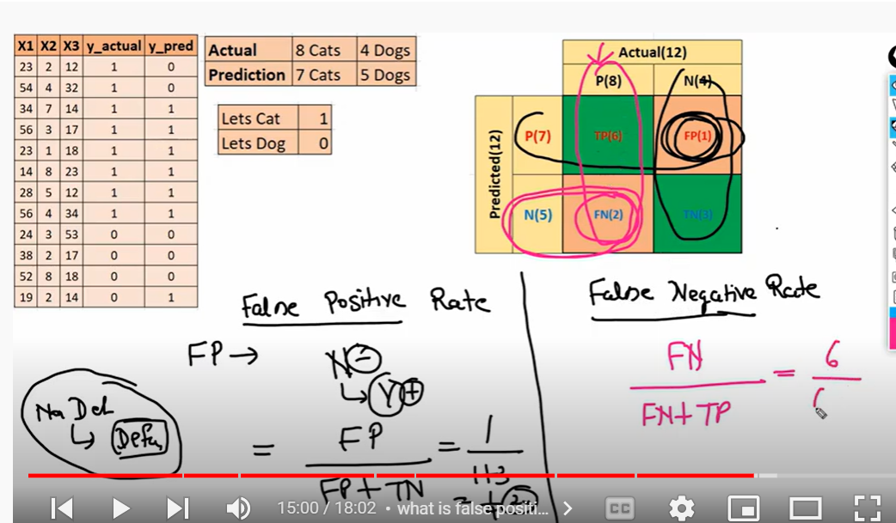

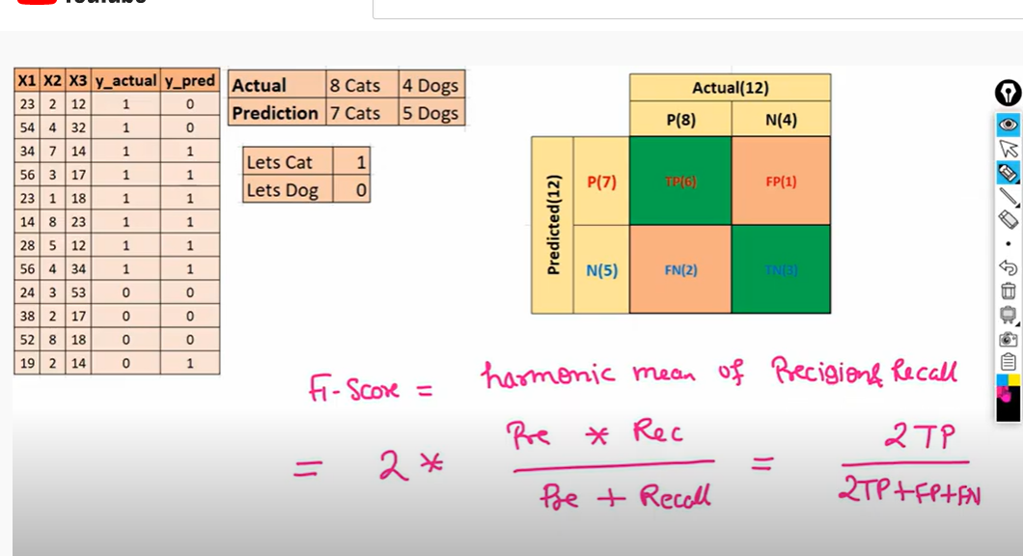

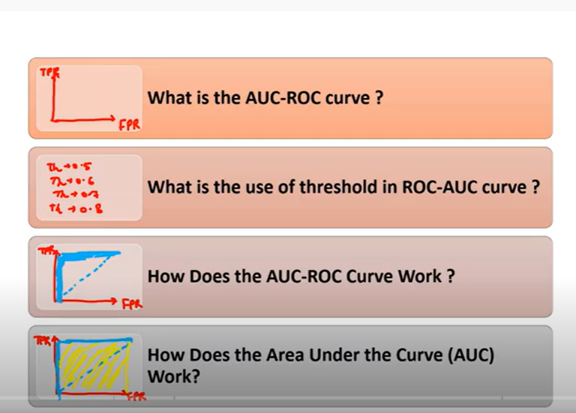

Auc curve drawn with help of True positive rate and false positive rate



Area under curve- receptor operating characteristic curve



Find TPR and FPR at different threshold

If I use 0.5 as threshold

All the point above 0.5=1

All points below 0.5=0

Threshold= 0.6

Different threshold values produces diff tpr and fpr

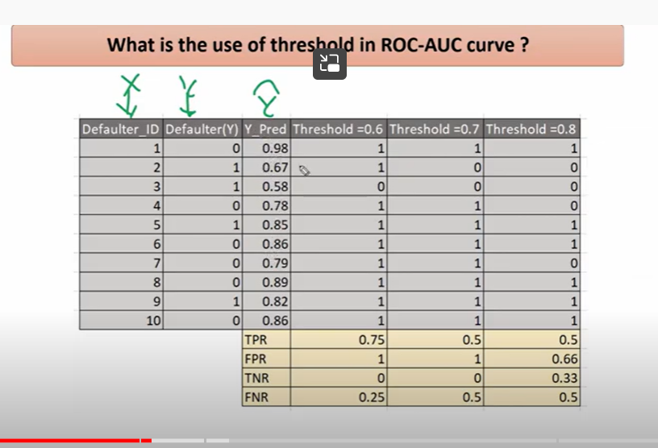

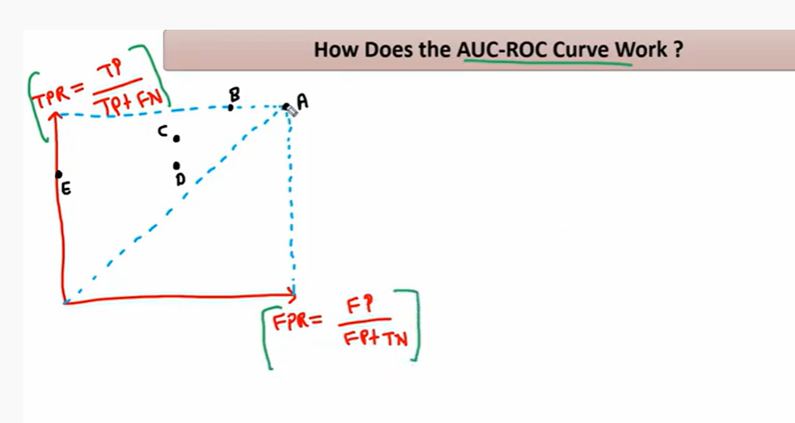

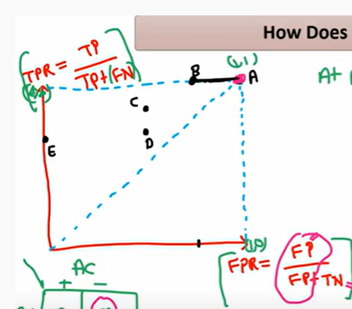

At point A

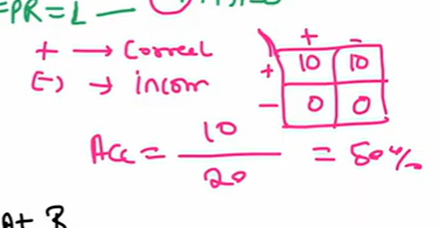

At B

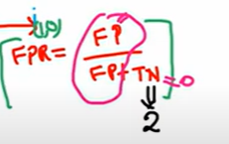

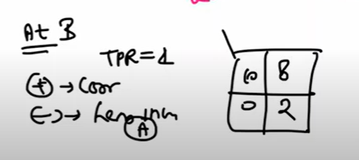

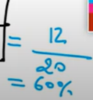

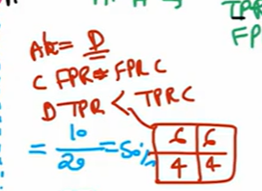

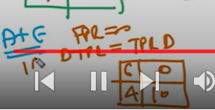

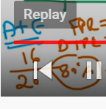

Threshold at e is good (best accuracy)

Best scenario is at p

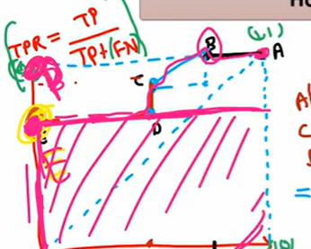

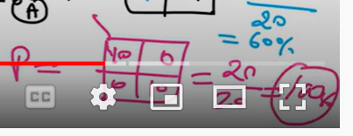

Area is 100

Example

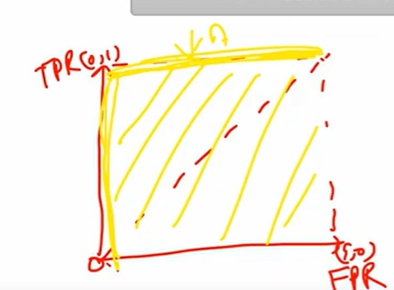

For above graph AUC is 1

Then distribution will be like this

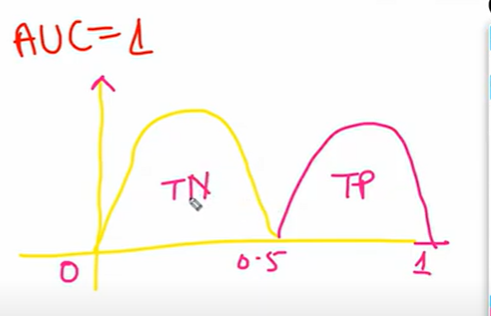

All positives and negatives are predicted correctly

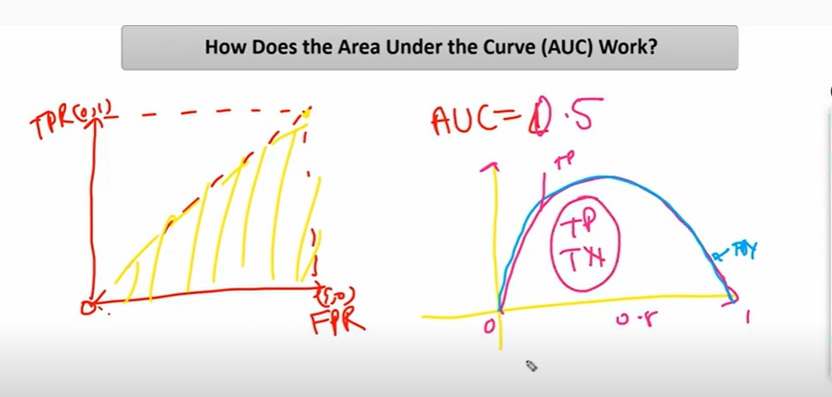

Tp and tn will be in same region

Positive and negative will be dicy

50percentage chances

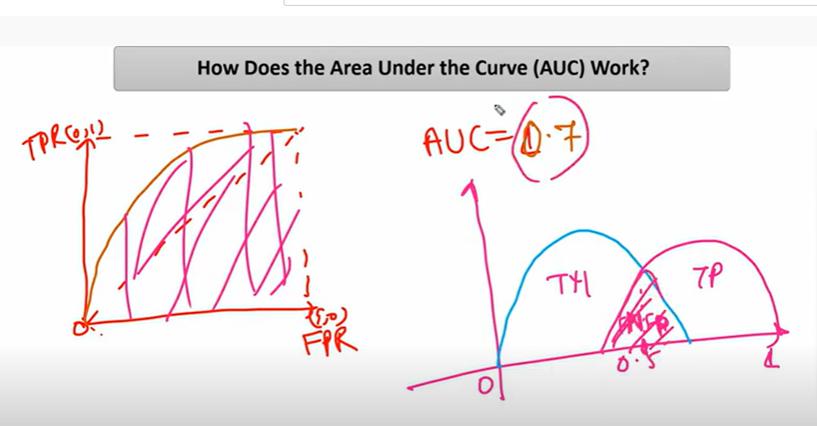

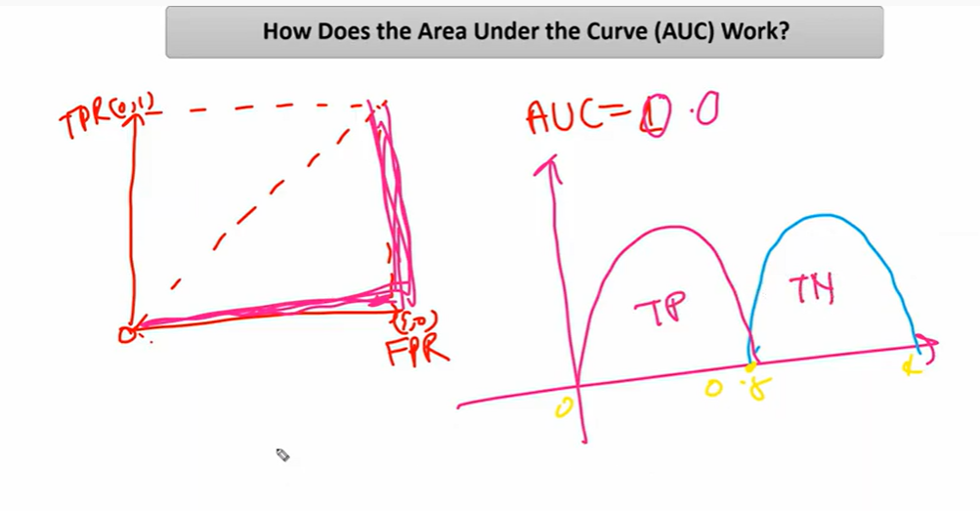all positive will be considered as negative and all negative will be classified as positives

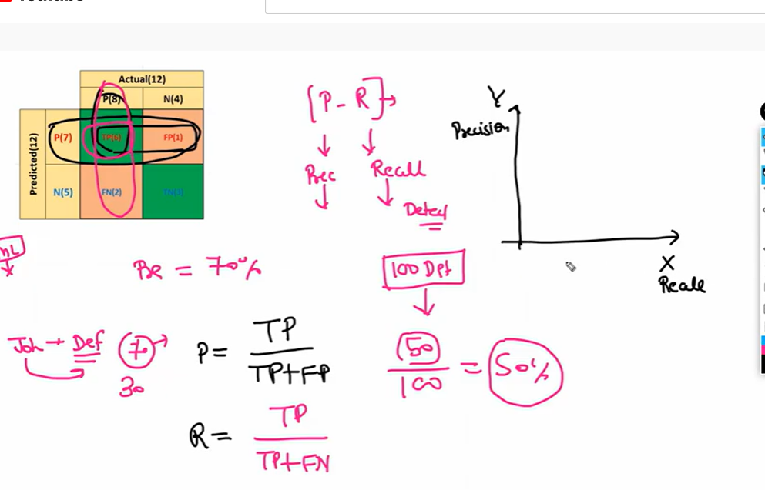

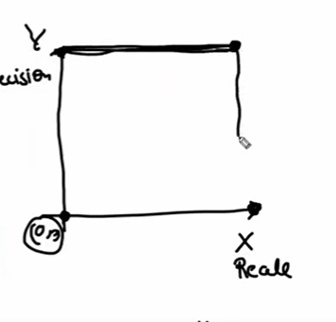

Model will be best at precision is 1 and recall =1

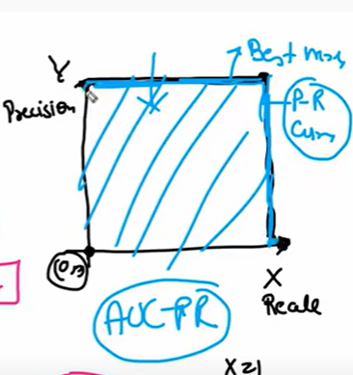

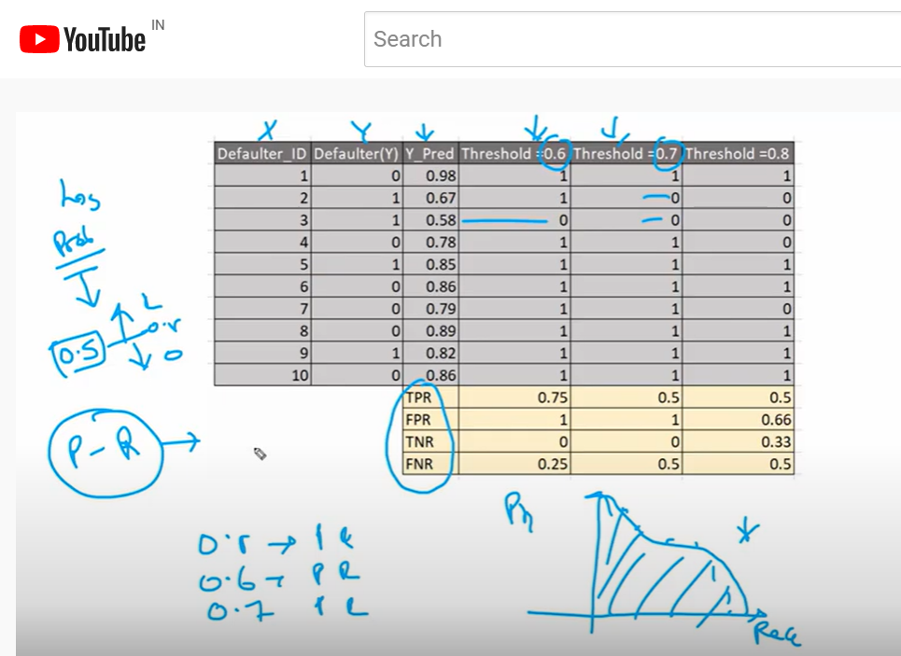

We will use precision and recall for imbalanced dataset

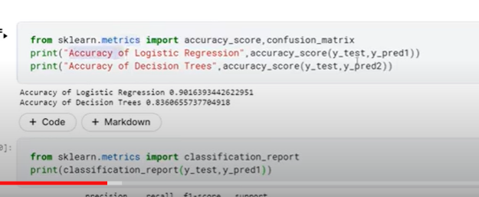

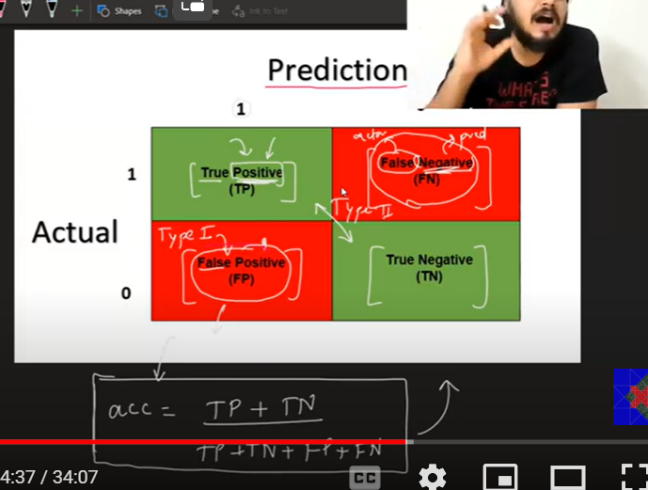

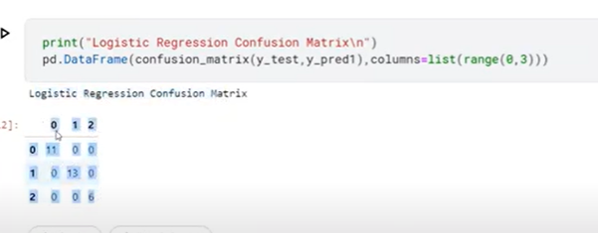

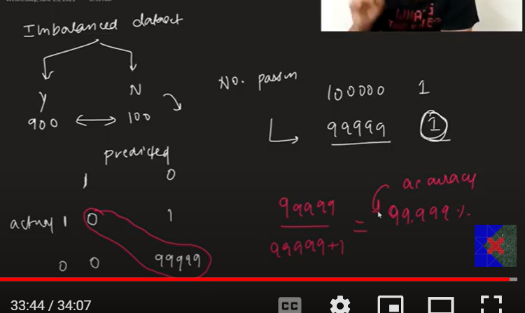

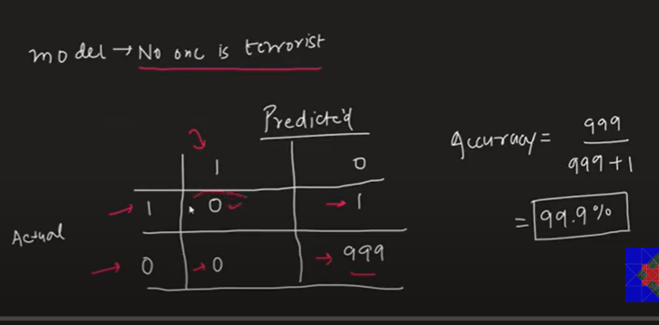

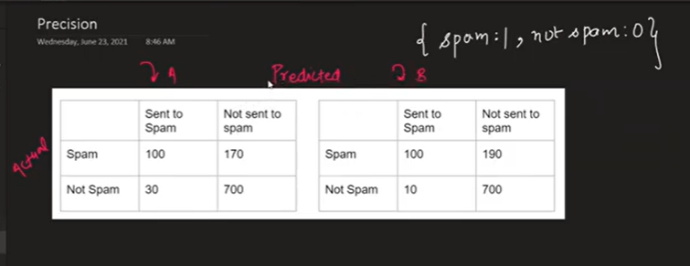

Which model A or B is correct?

Depends on fault

Main problem here is considering non spam email as spam may loose information

False positive is main problem

Here we wil select model which has less false positive

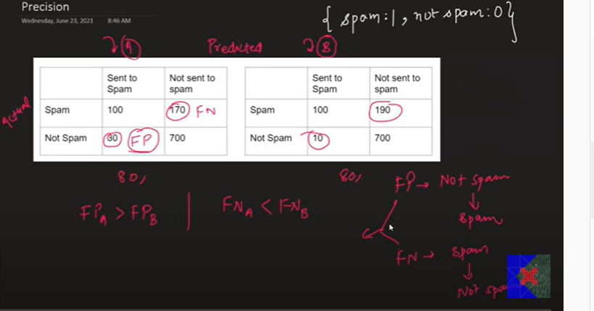

Model B is good as it has less false B

Its called precision

Proportion of predicted positive is true positives

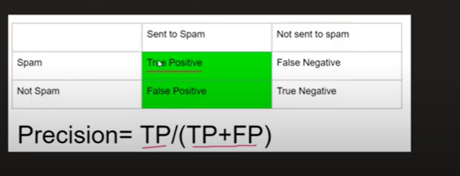

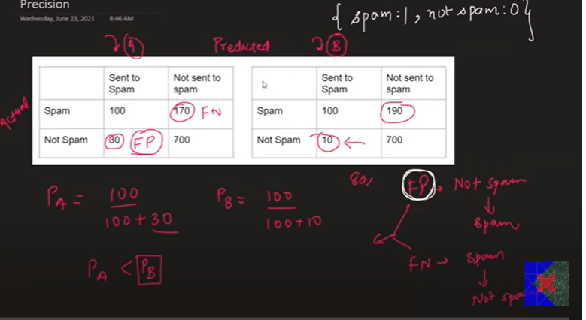

Precision b is higher than precision B

Recall

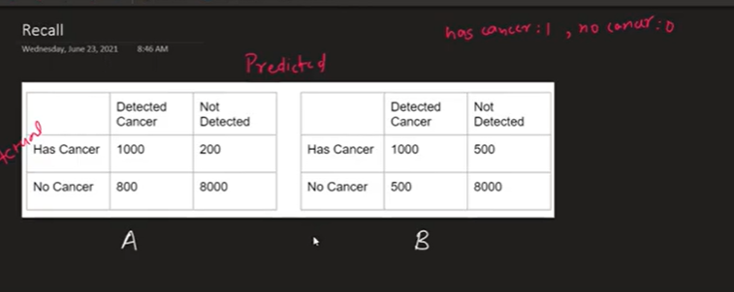

Here false negative cause main problem

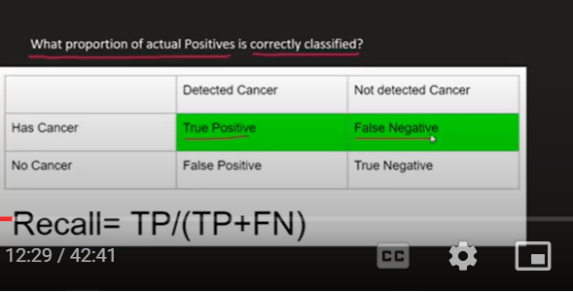

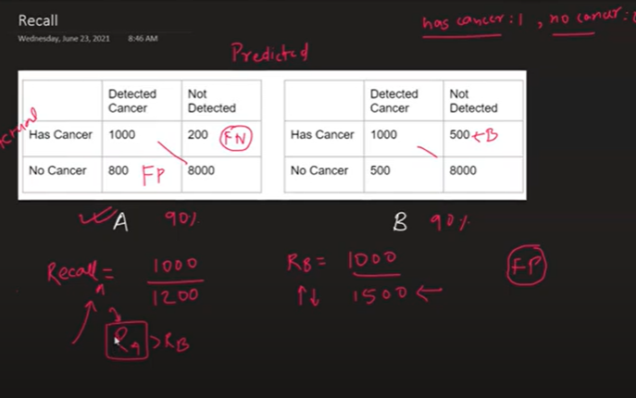

Type 2 makes problem then recall

Type 1 makes problem: high precision model should be selected

When we wanted predict cat or dog both precision and recall imp

In this situation we use f1 score

Avg of precision and recall( harmonic mean)



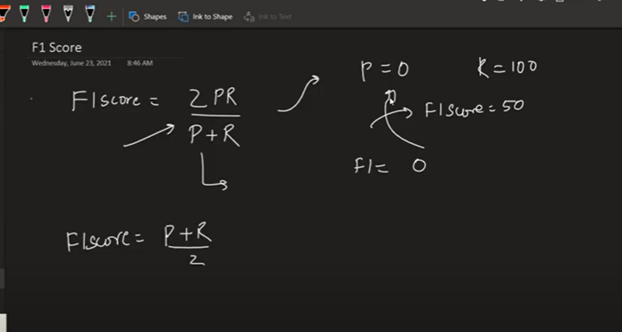

F1 score will be towards lower value side(either precision or recall)

Harmonic mean : Precision or recall lo ee value takkuva unna model ni penalize chestundi

Precision recall same: then arithmetic mean

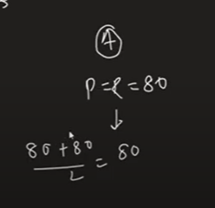

Harmonic mean

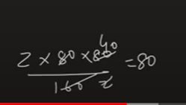

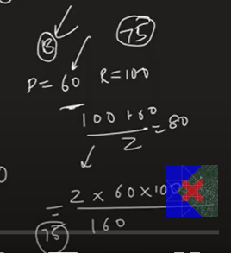

Harmonic mean penalize if any value is less where as athematic mean will not be

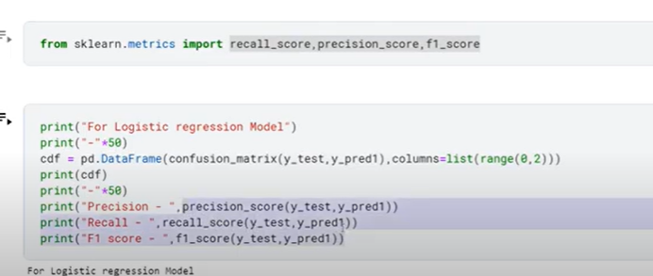

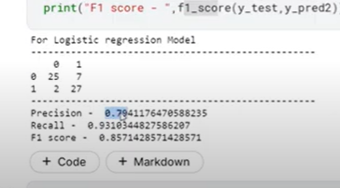

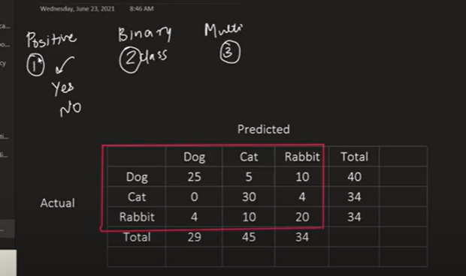

Binary classification

Multilevel classification

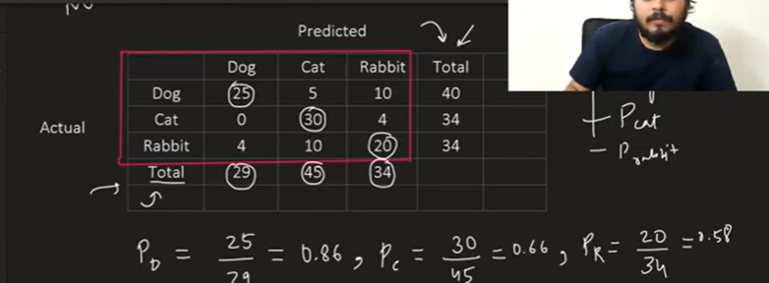

Macro precision : avg of 3 precision values

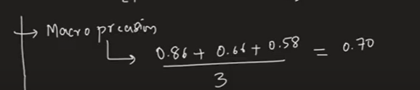

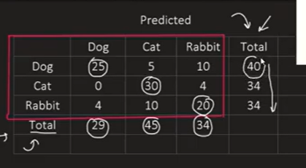

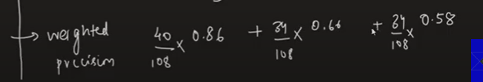

For balanced: macro precision

Weighted will be for imbalanced

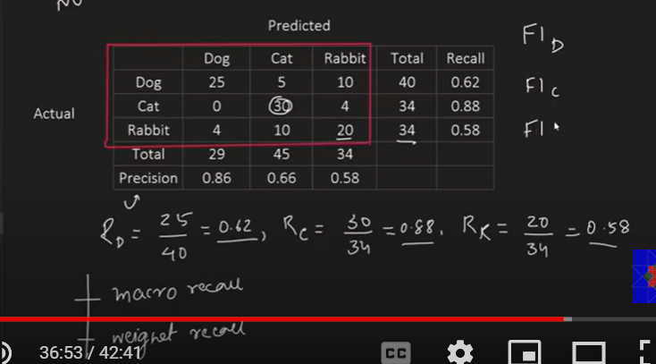

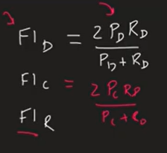

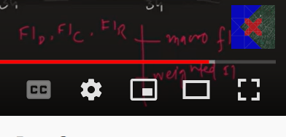

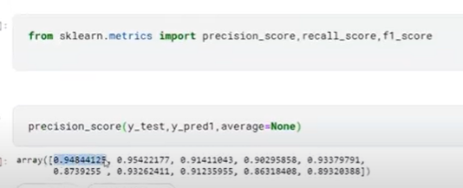

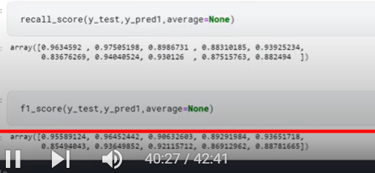

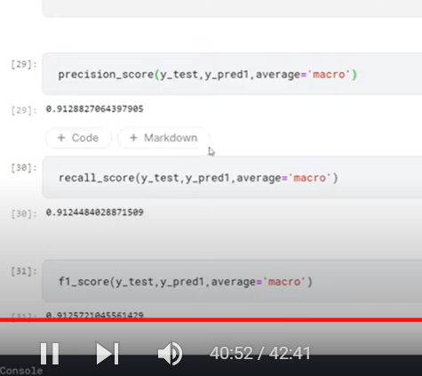

Weighted

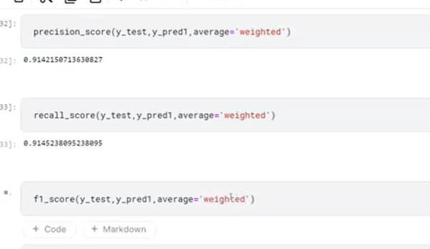

Or we can use classificassion report

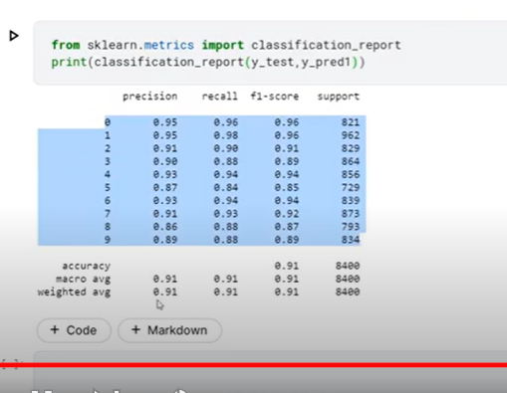

**Regression Metrics | MSE, MAE & RMSE | R2 Score & Adjusted R2 Score**

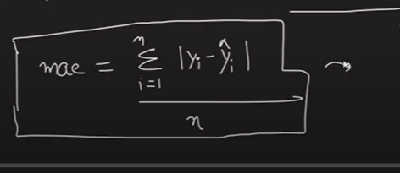

Advantage:

Same unit: MAE is exactly in the units of Y(OUTPUT VALUE)

Robust to outliers(handles outliers)

Disadvantage:

Modular function is not differentiable(optimization technical like gradient descent will not be used )



MSE;



Graph is differentiable at all points

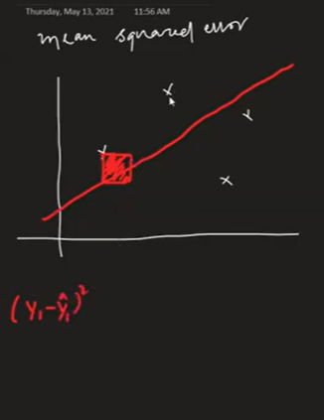

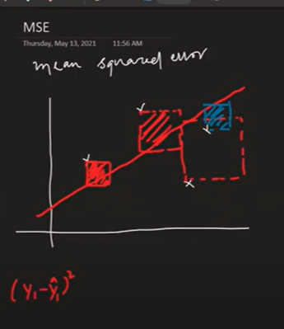

Calculate area and try to minimize

Advantage: differentiable

Disadvantage: MSE is square of Y

Penalize outliers much(NOT ROBOST TO OUTLIERS)

High outliers: MAE

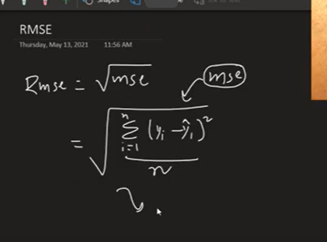

Graph is differentiable

Scale: equal to y

Not robust to outliers

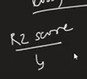

How well our model is performing ‘

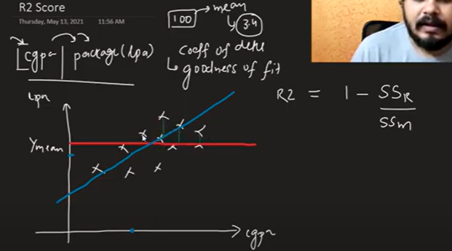

SSr: sum square error at regression line

SSm: sum square error at mean

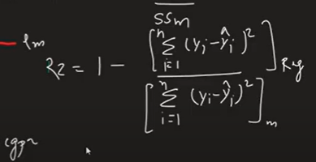

R2=0

Means SSr and SSM is equal, means model is not performing well

1-SSr/SSM

1-1=0

It means there is no use of independent value when predicting y

R2=1- good model

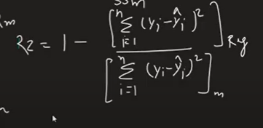

When reg or SSr should be zero it means no error on regression line

1-0/

So

R2 must be towards 1 not towards zero

**When do r2 score is negative?**

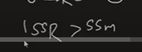

**It means regression line is doing worst than mean line**

**It means our algorithm is not able to understand data**

**Our data is not linear**

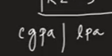

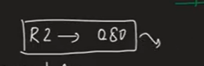

**It means our input value able to interpret variance on lpa column at 80 percentage**

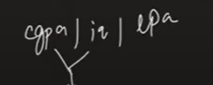

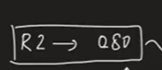

**It means our input values(CGPA and IQ) able to interpret variance on lpa column at 80 percentage**

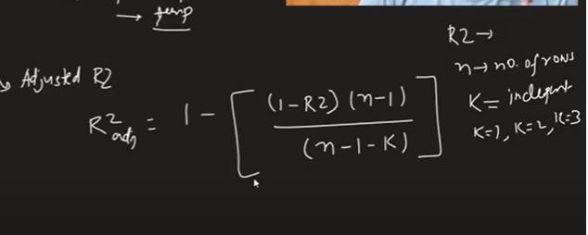

**When un relevant column is added :**

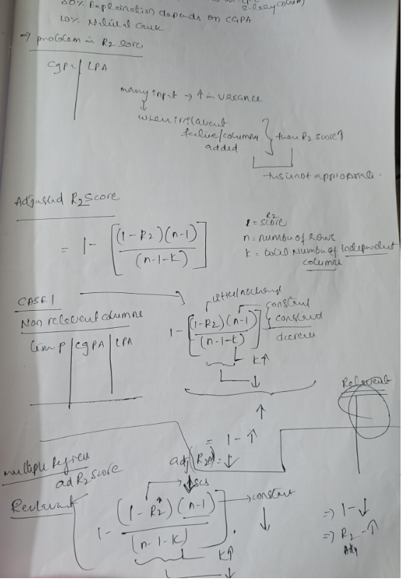

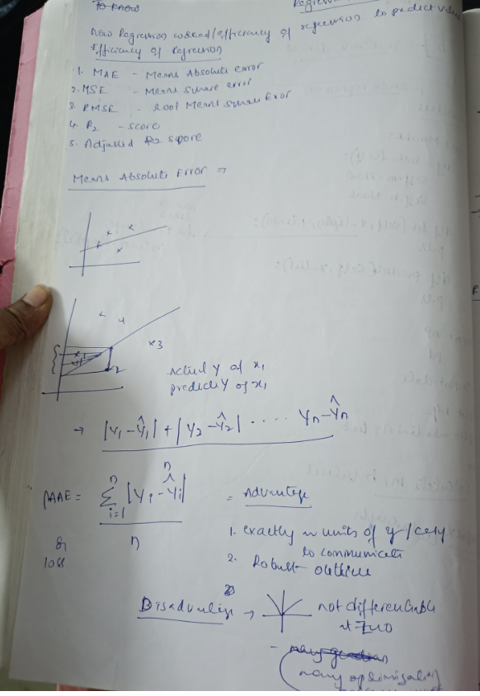

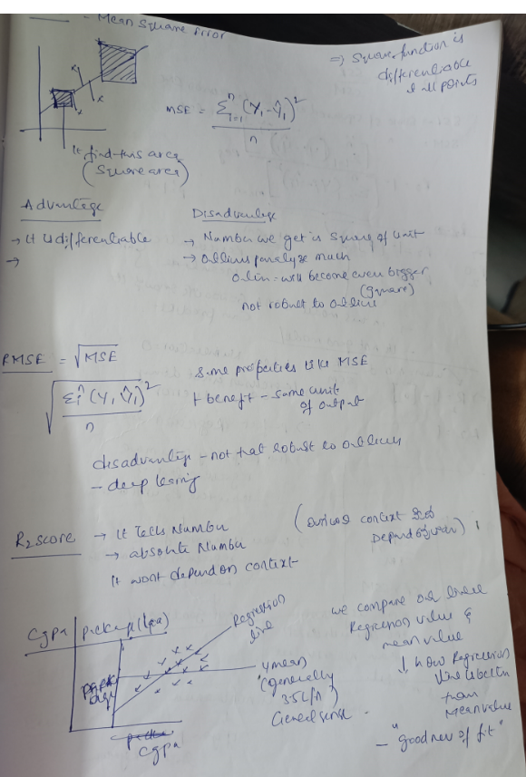

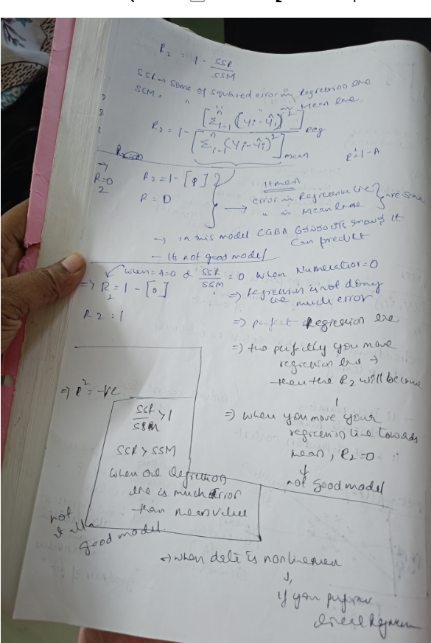

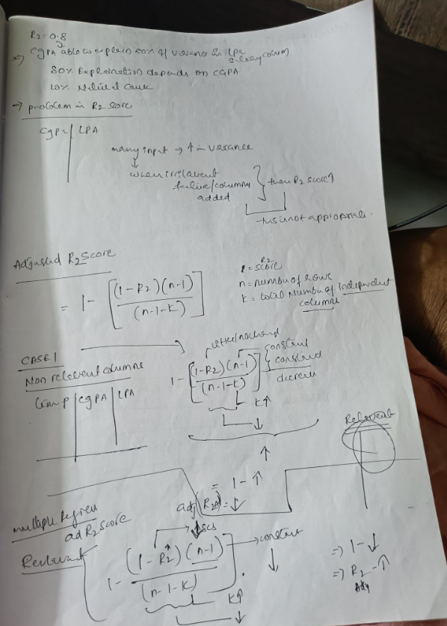

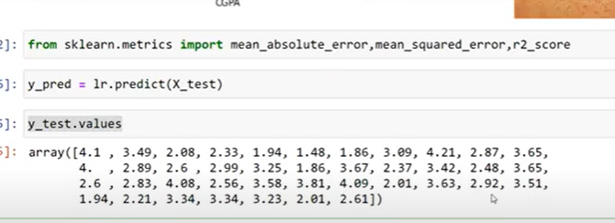

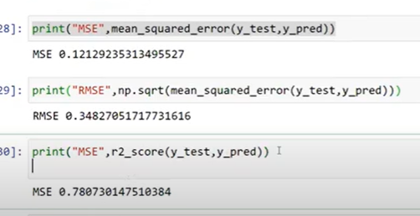

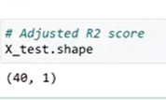

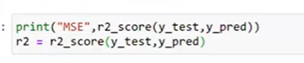

**adjusted r2**

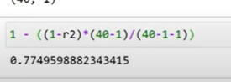

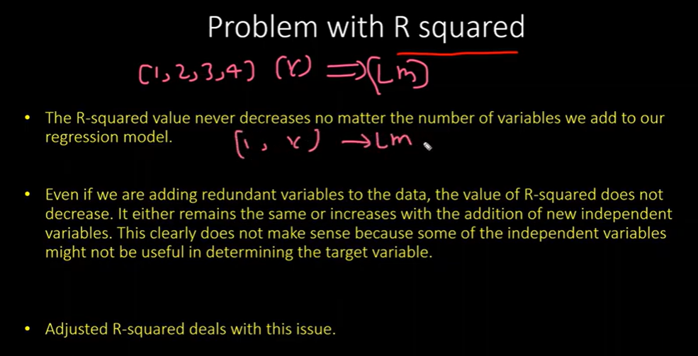

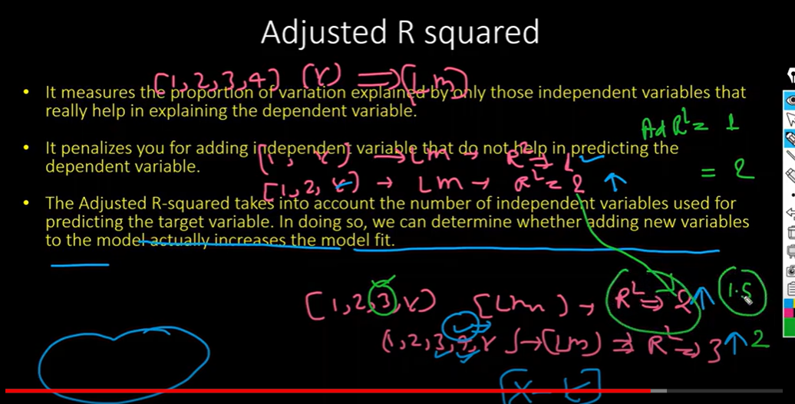

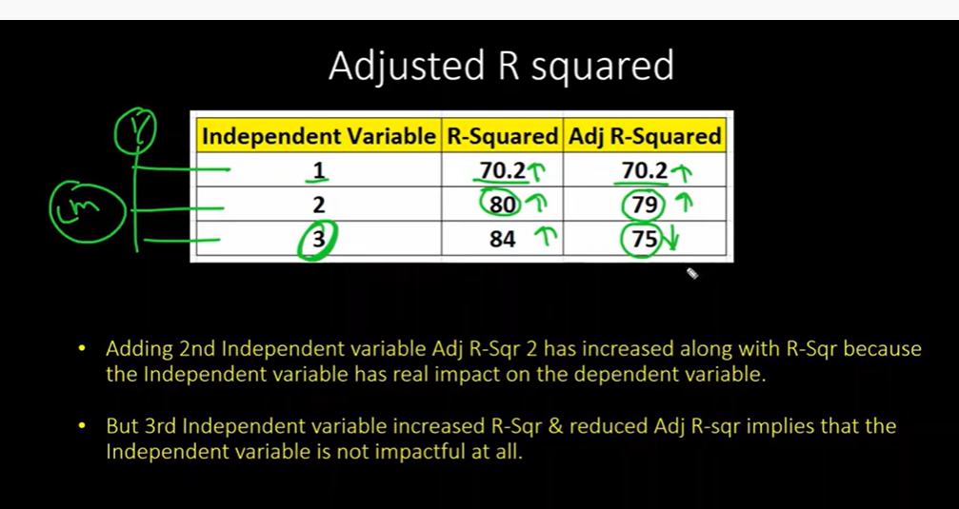

**Assumptions of Linear Regression | Part1**

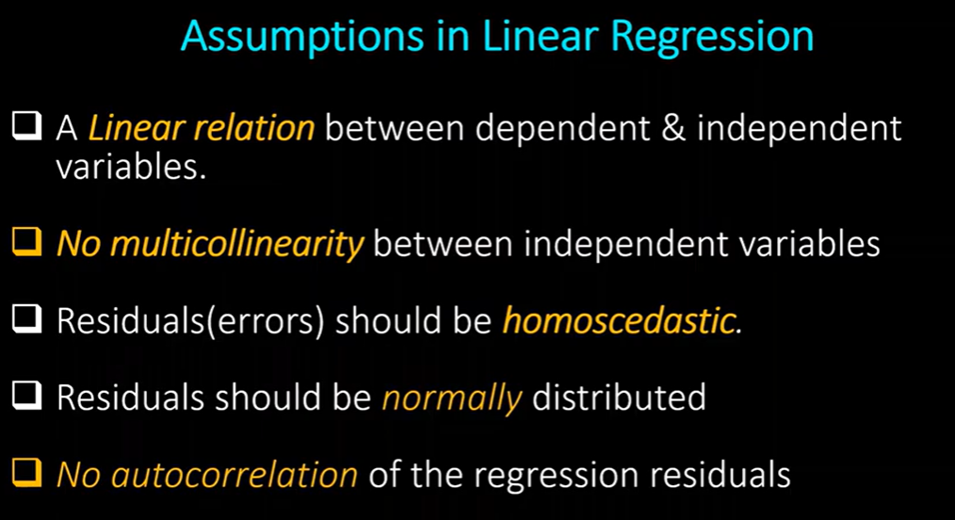

Values must be normally distributed

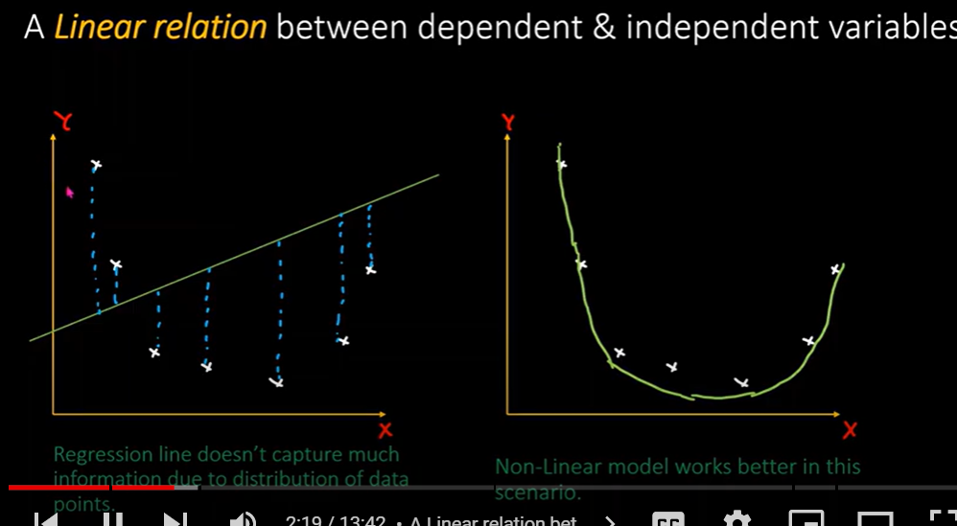

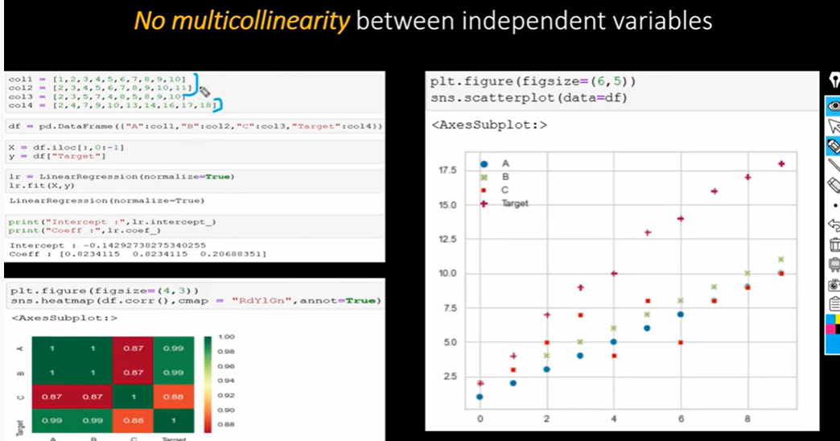

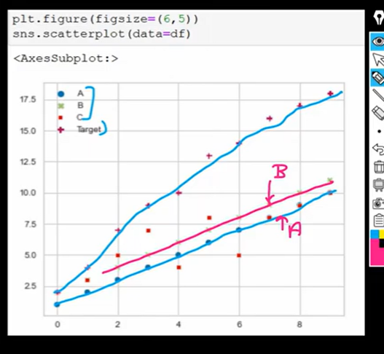

A, B highly correlated

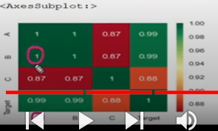

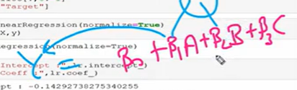

It means beta1 has same influence like beta2 on output

In that case must remove 1

Otherwise computational cost high

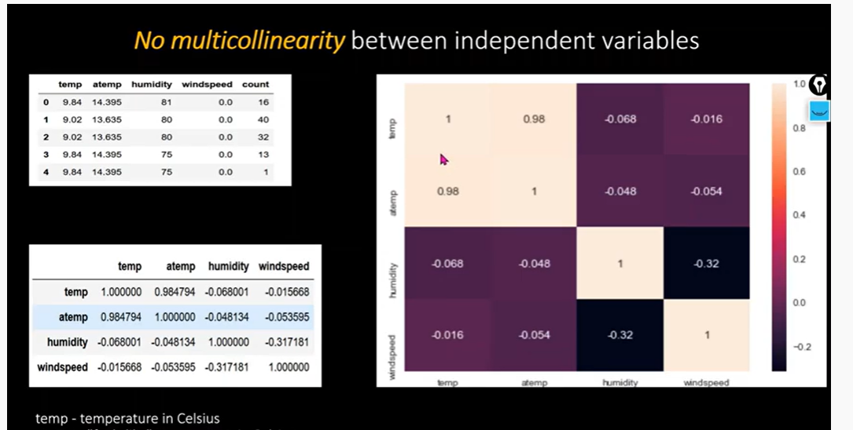

Temp and atemp are same

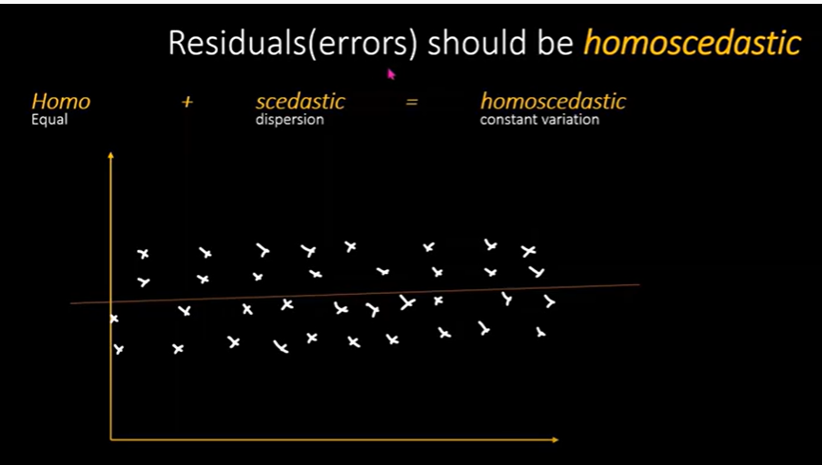

Graph between -Residual(y),Predicted(x)—distribution of values must be constant like above or distribution of variance across regression line

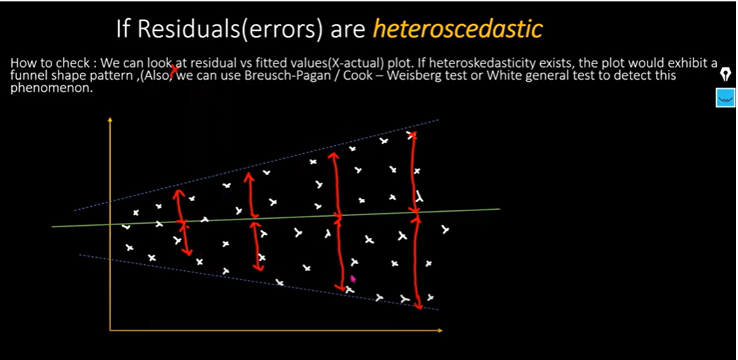

As predicted value increase the variance also gets increased

More errors in prediction



Overcome log(y)

Or squareroot(y)

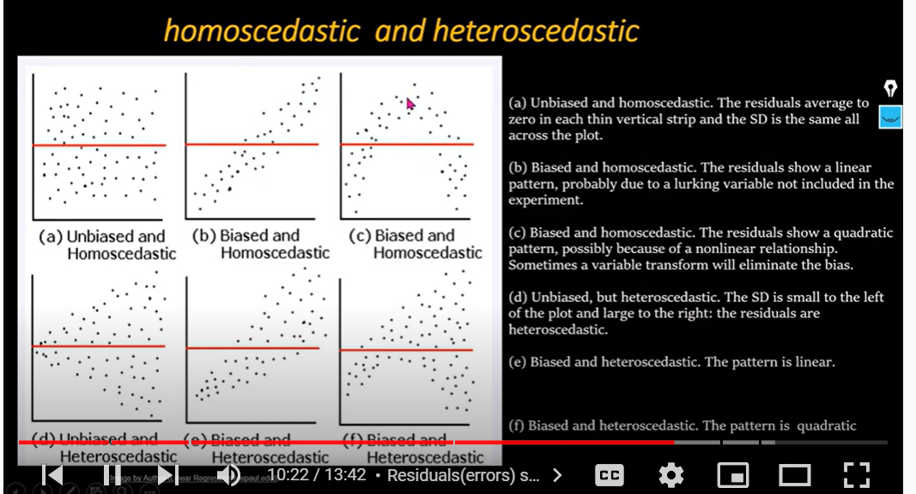

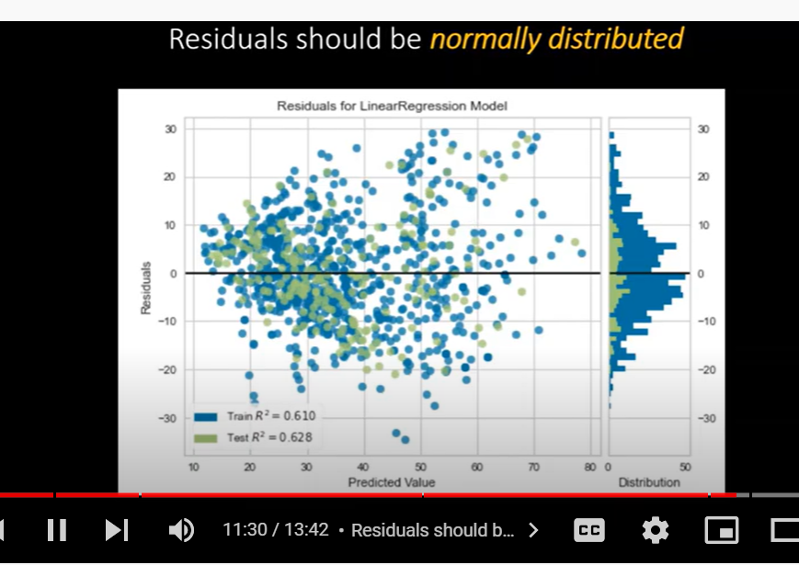

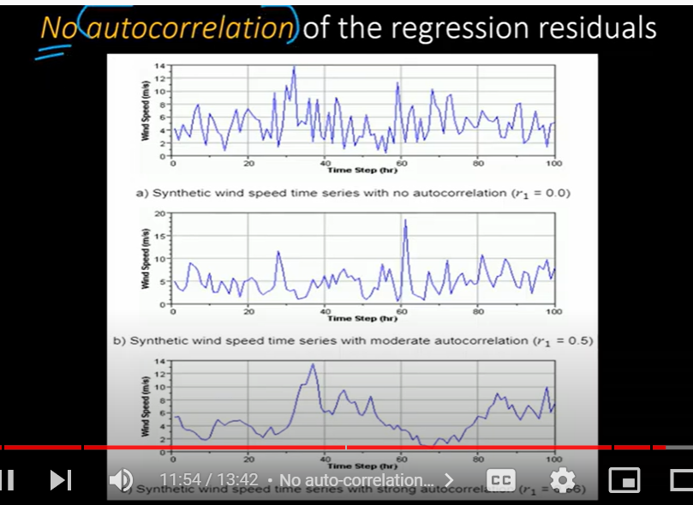

Like time series

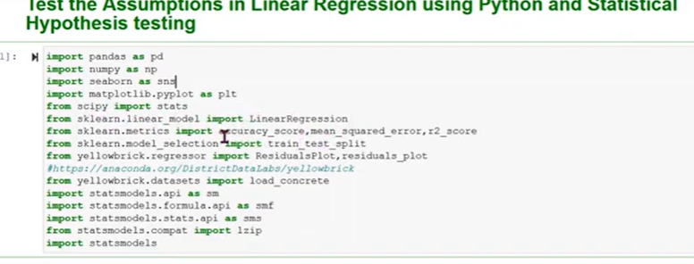

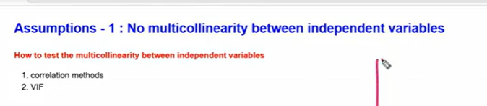

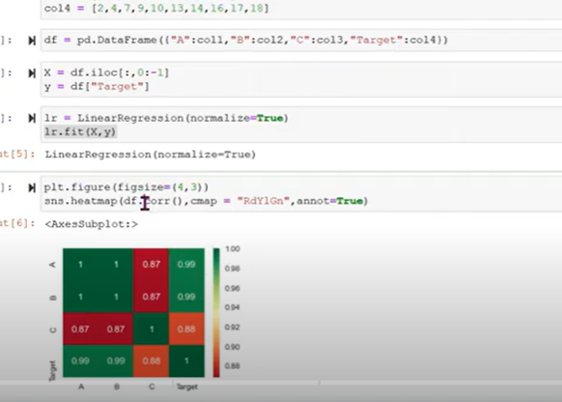

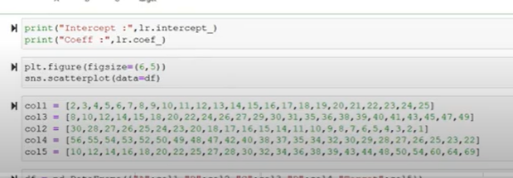

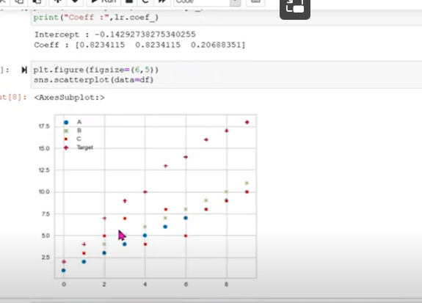

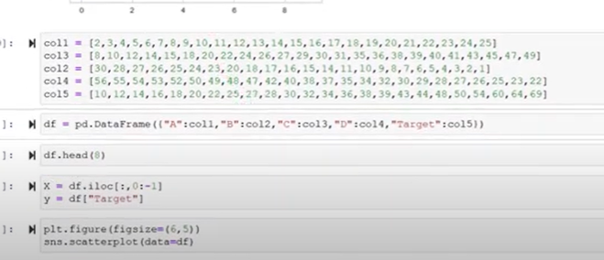

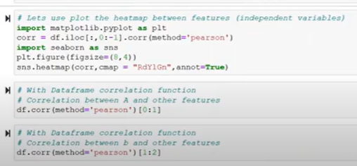

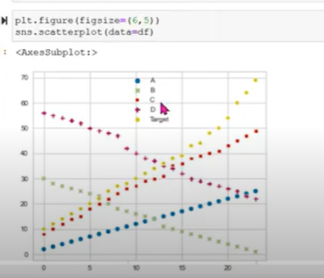

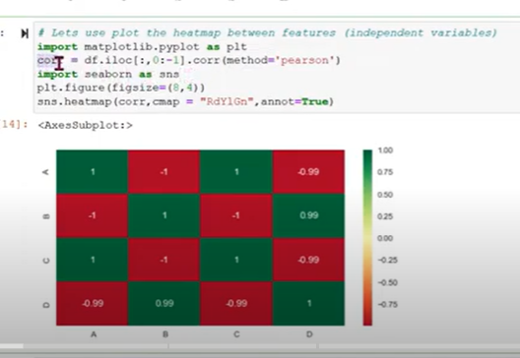

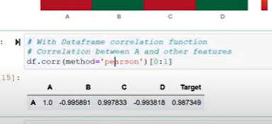

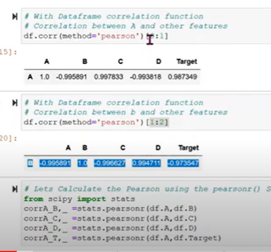

[Verifying the Assumptions of Linear Regression using Python and Stats Library|Part 2|Machines Learn - YouTube](https://www.youtube.com/watch?v=PymiDoj1_xg&list=PLYkT78pxW-ovFTqO64s7diOhDrY-N85V7&index=15)

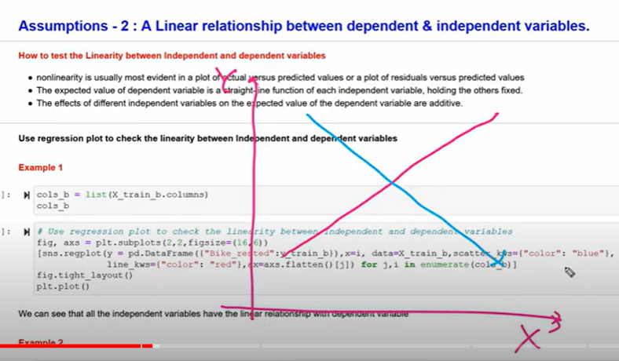

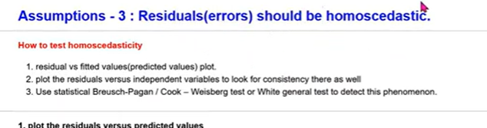

Residuals

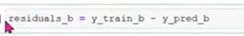

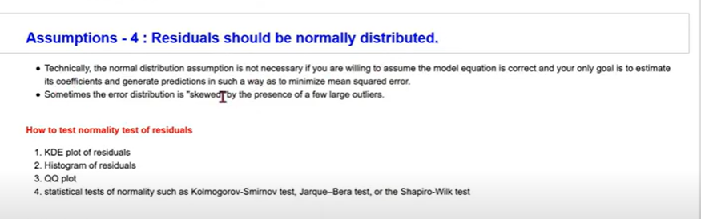

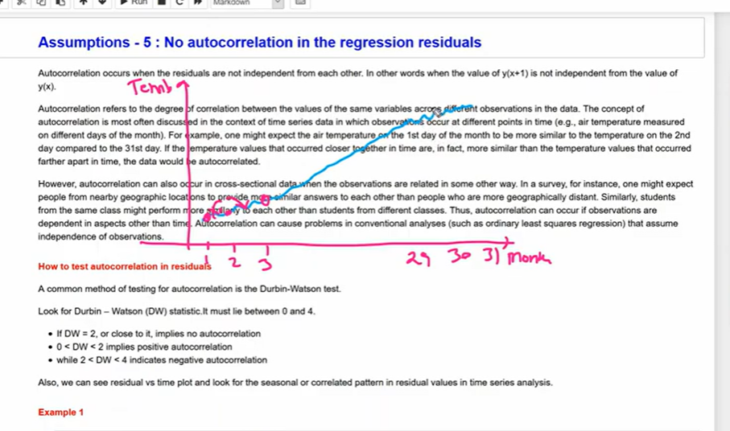

**Cluster Validation**



Randomness : no relation or similar type data is not there

Non randomness: patterns or there





Compare two clusters which is best

4th is supervised

5th is both supervised and unsupervised

--------------------------------------------------------------------------------------------------------------------------------------------

 for validation

It didn’t use ground truth(no reference)

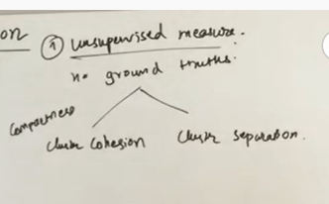

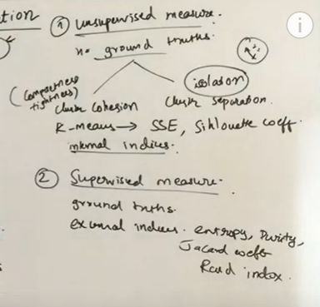



Entropy : amount of disorder in system





Cohesion: how similar data points within cluster

Separation : how different data points from cluser A to B

Cohesion =

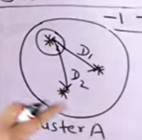

Avg od distance within cluster

**Separation:**

Distance of point in A to distance of points in B





Silhoute coefficient for one particular data point

b-a

to normalize

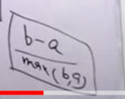

Do it for all points

Finally find avg for all data points

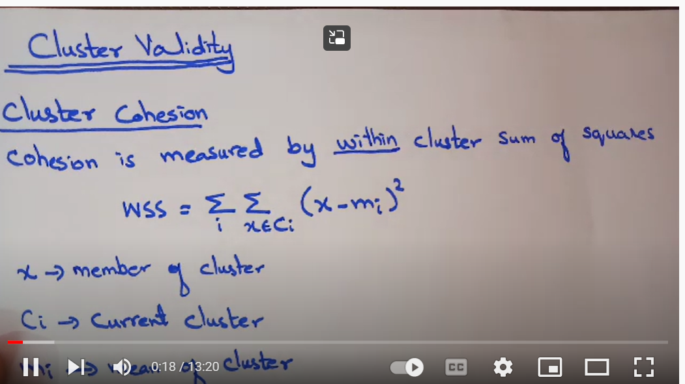

Mi= mean of cluster

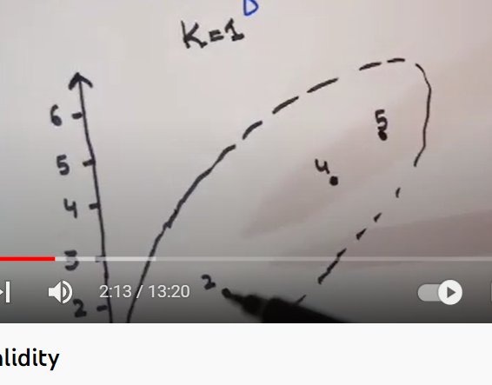

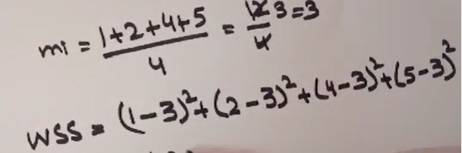

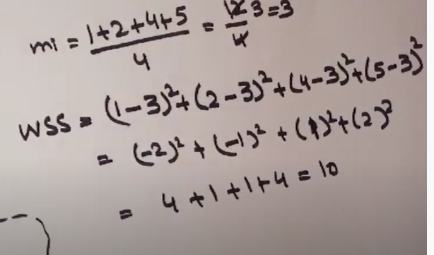



Since one cluster

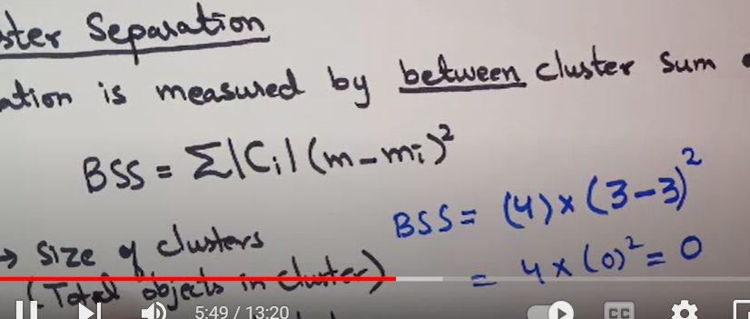



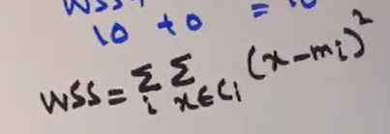

Mean of cluster 1 and 2

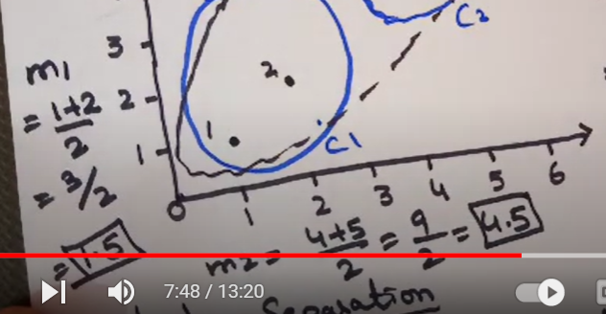

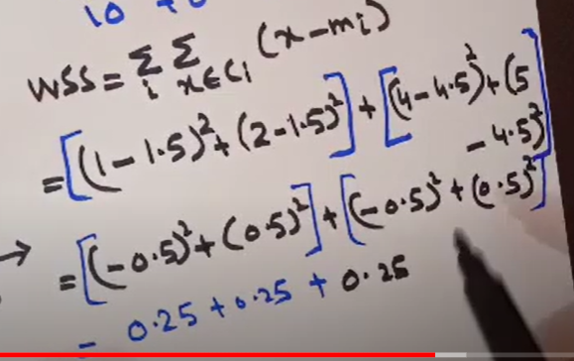





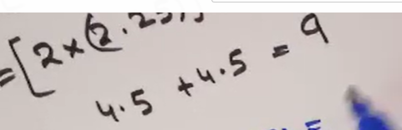

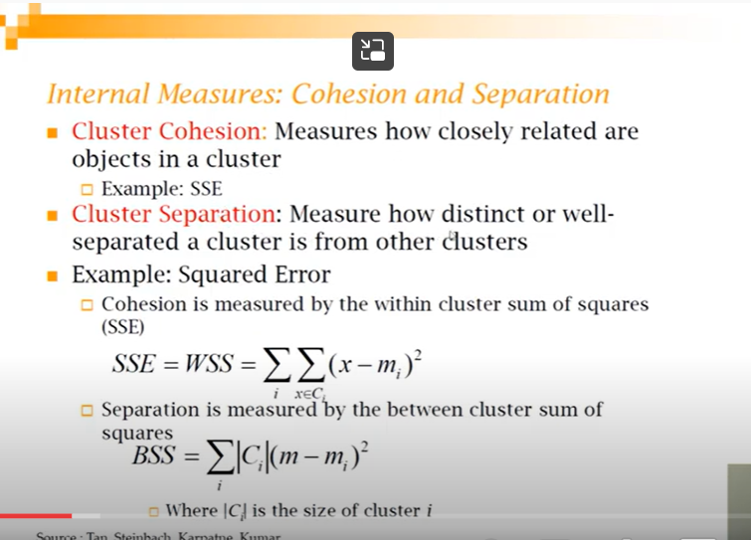



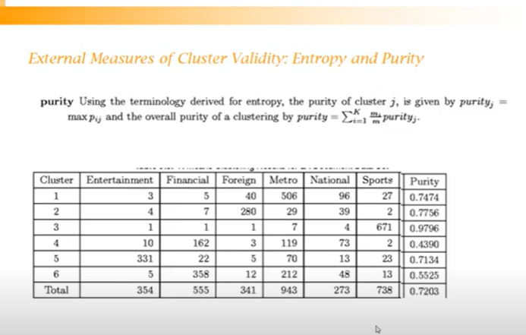

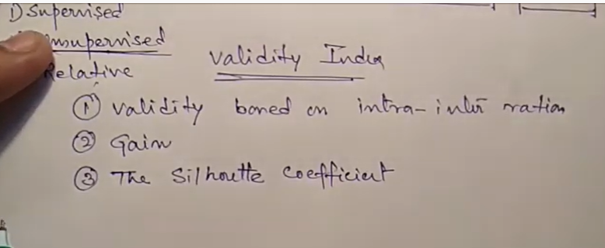

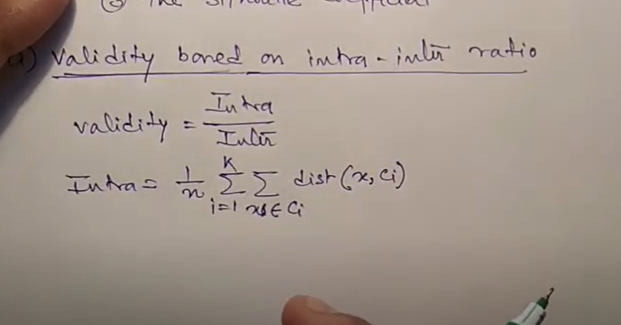

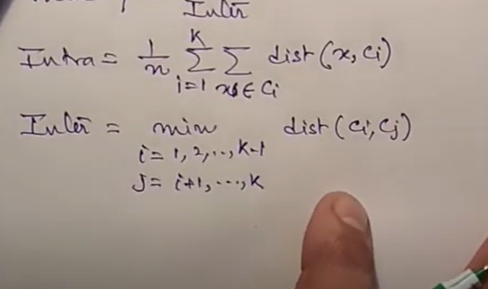



[51. Unsupervised method: Validity, Gain, Silhouette coefficient Cluster quality evaluation (Part 1) - YouTube](https://www.youtube.com/watch?v=MyjmjzDbccw)

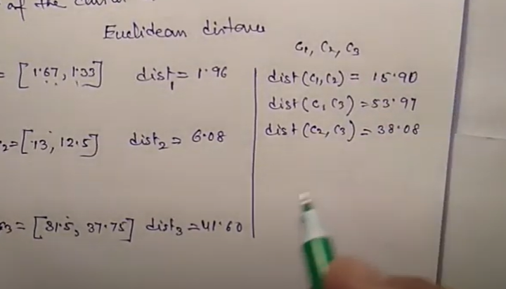



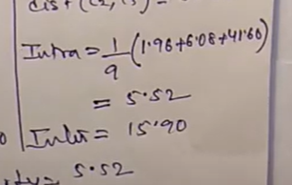

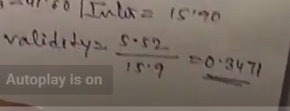

Validity should be min for better cluster

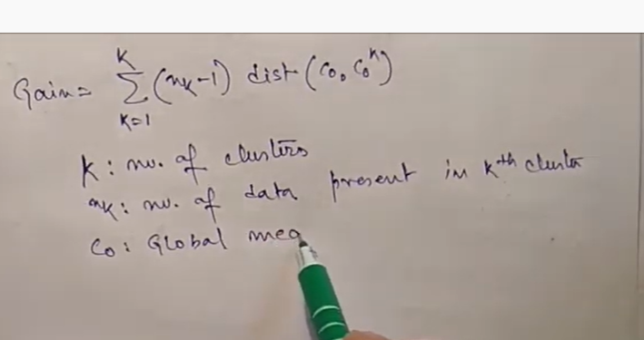

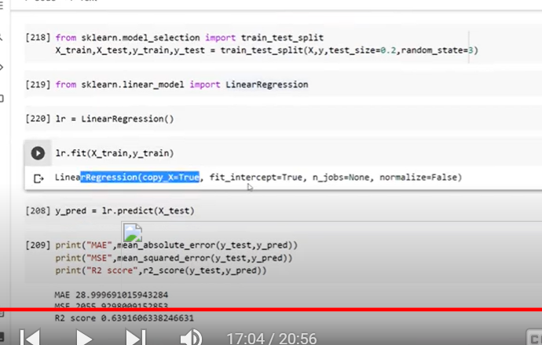

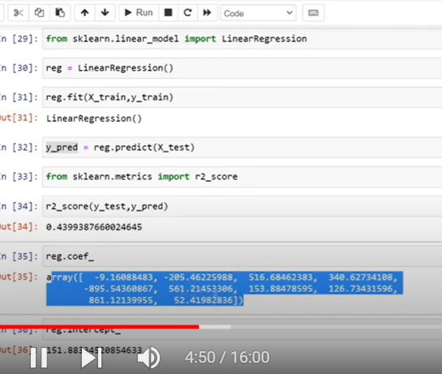

**Detecting Multicollinearity with VIF – Python**

* Last Updated : 29 Aug, 2020

Multicollinearity occurs when there are two or more independent variables in a multiple regression model, which have a high correlation among themselves. When some features are highly correlated, we might have difficulty in distinguishing between their individual effects on the dependent variable. Multicollinearity can be detected using various techniques, one such technique being the **Variance Inflation Factor**(**VIF**).

In VIF method, we pick each feature and regress it against all of the other features. For each regression, the factor is calculated as :

Where, [R-squared](https://www.geeksforgeeks.org/ml-r-squared-in-regression-analysis/) is the coefficient of determination in linear regression. Its value lies between 0 and 1.

As we see from the formula, greater the value of R-squared, greater is the VIF. Hence, greater VIF denotes greater correlation. This is in agreement with the fact that a higher R-squared value denotes a stronger collinearity. Generally, a VIF above 5 indicates a high multicollinearity.

**Implementing VIF using statsmodels:**

*statsmodels* provides a function named **variance_inflation_factor()** for calculating VIF.

***Syntax :****statsmodels.stats.outliers_influence.variance_inflation_factor(exog, exog_idx)*

***Parameters :***

* *exog : an array containing features on which linear regression is performed.*
* *exog_idx : index of the additional feature whose influence on the other features is to be measured.*

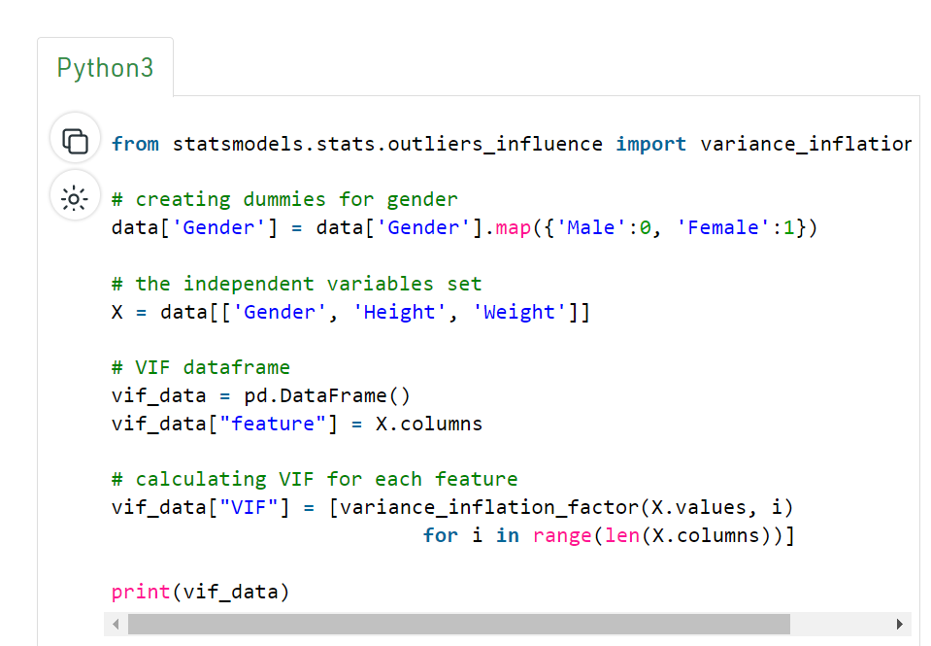

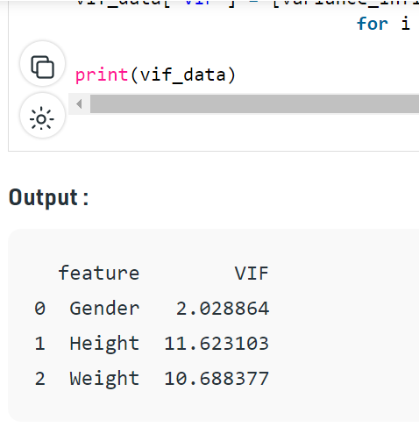

As we can see, height and weight have very high values of VIF, indicating that these two variables are highly correlated. This is expected as the height of a person does influence their weight. Hence, considering these two features together leads to a model with high multicollinearity.

Take one feature as dependent variable and all other as independent variable keep it as regression

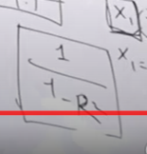

If r2 is high then denominator low and vif also increase

For higher r2 leads to higher vif

It generates vif for all other independent variables

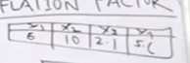

If vif is above 5 will be considered as high and those features will be removed

It means other variables are explaining these variables

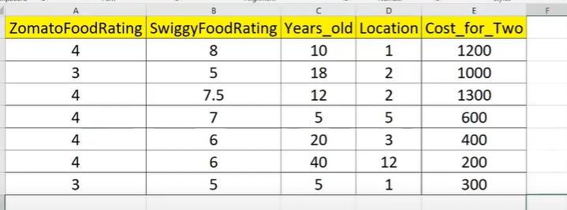

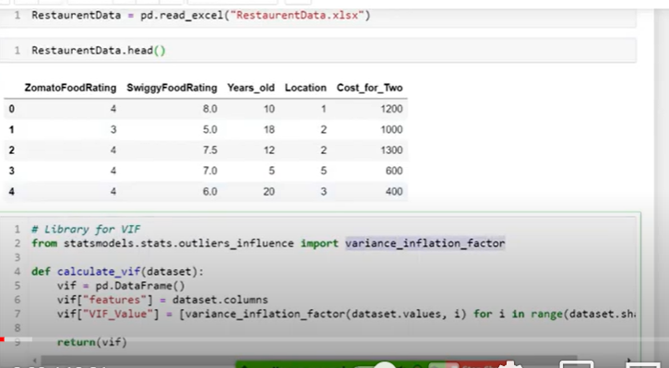

[VIF Application in Python | VIF In python | Variance Inflation Factor In Python - YouTube](https://www.youtube.com/watch?v=6JpmgzCAusI)

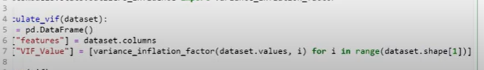

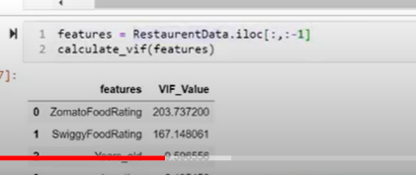

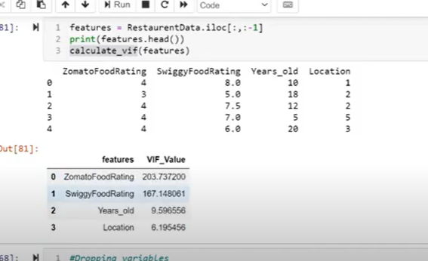

We should drop one of variable Zomato, swiggy rating

Which one should be removed- we should know which variable has high correlated with target variable keep that column and remove other column